Software Requirements Specification

for

Espina’s Bikes

Version 1.0

Prepared by

Group Name: Group 3

|  |  |  |
| --- | --- | --- |
| Jaime Jahuey | <student #> | Jahuey@email.uscupstate.edu |
| David Krechko | <student #> | Krechkod@email.uscupstate.edu |
| Daniel Espina | <student #> | espina@email.uscupstate.edu |
| Alfonso Quistian | <student #> | Quistian@email.uscupstate.edu |

|  |  |
| --- | --- |
| Instructor: | Dr. Schwartz |
| Course: | CSCI540 |
| Date: | <place the date of submission here> |

Contents

Revisions ii

1 Introduction 1

1.1 Document Purpose 1

1.2 Product Scope 1

1.3 Intended Audience and Document Overview 1

1.4 Definitions, Acronyms and Abbreviations 1

1.5 Document Conventions 1

1.6 References and Acknowledgments 2

2 Overall Description 3

2.1 Product Perspective 3

2.2 Product Functionality 3

2.3 Users and Characteristics 3

2.4 Operating Environment 3

2.5 Design and Implementation Constraints 4

2.6 User Documentation 4

2.7 Assumptions and Dependencies 4

3 Specific Requirements 5

3.1 External Interface Requirements 5

3.2 Functional Requirements 6

3.3 Behaviour Requirements 6

4 Other Non-functional Requirements 6

4.1 Performance Requirements 6

4.2 Safety and Security Requirements 7

4.3 Software Quality Attributes 7

5 Other Requirements 7

Appendix A – Data Dictionary 8

Appendix B - Group Log 9

# 

Revisions

| Version | Primary Author(s) | Description of Version | Date Completed |
| --- | --- | --- | --- |
| 1.0 | Jaime Jahuey  David Krechko  Daniel Espina  Alfonso Quistian | Primary Draft | 10/02/15 |
|  | Jaime Jahuey  David Krechko  Daniel Espina  Alfonso Quistian |  |  |
|  | Jaime Jahuey  David Krechko  Daniel Espina  Alfonso Quistian |  |  |

# Introduction

*This section will describe a general view of the software EspinasBikes.*

## Document Purpose

<Identify the product whose software requirements are specified in this document, including the revision or release number. Describe the scope of the product that is covered by this SRS, particularly if this SRS describes only part of the system or a single subsystem.

TO DO: Write 1-2 paragraphs describing the purpose of this document as explained above.>

## Product Scope

The application EspinasBikes will only require an android phone or device. The application will create a local database on the user’s device and will store all of his information in the device. The installation of this application on his device will make it more feasible for him to manage his bike shop on the go since the application at his convenience on his mobile phone or device.

## Intended Audience and Document Overview

<Describe the different types of reader that the document is intended for, such as developers, project managers, marketing staff, users, testers, and documentation writers (In your case it would probably be the “client” and the professor). Describe what the rest of this SRS contains and how it is organized. Suggest a sequence for reading the document, beginning with the overview sections and proceeding through the sections that are most pertinent to each reader type.>

This documentation is mainly intended for the bike shop owner or any other bike shop owner that would like to use this application.

## Definitions, Acronyms and Abbreviations

<Define all the terms necessary to properly interpret the SRS, including acronyms and abbreviations. You may wish to build a separate glossary that spans multiple projects or the entire organization, and just include terms specific to a single project in each SRS.

TO DO: Please provide a list of all abbreviations and acronyms used in this document sorted in alphabetical order.>

## Document Conventions

<In general this document follows the IEEE formatting requirements. Use Arial font size 11, or 12 throughout the document for text. Use italics for comments. Document text should be single spaced and maintain the 1” margins found in this template. For Section and Subsection titles please follow the template.

TO DO: Describe any standards or typographical conventions that were followed when writing this SRS, such as fonts or highlighting that have special significance. Sometimes, it is useful to divide this section to several sections, e.g., Formatting Conventions, Naming Conventions, etc.>

## References and Acknowledgments

<List any other documents or Web addresses to which this SRS refers. These may include user interface style guides, contracts, standards, system requirements specifications, use case documents, or a vision and scope document.

TO DO: Use the standard IEEE citation guide for this section. An example citation guide is posted for you on the website.>

# Overall Description

## Product Perspective

<Describe the context and origin of the product being specified in this SRS. For example, state whether this product is a follow-on member of a product family, a replacement for certain existing systems, or a new, self-contained product. If the SRS defines a component of a larger system, relate the requirements of the larger system to the functionality of this software and identify interfaces between the two. In this part, make sure to include a simple diagram that shows the major components of the overall system, subsystem interconnections, and external interface. In this section it is crucial that you will be creative and provide as much information as possible.

TO DO: Provide at least one paragraph describing product perspective. Provide a general diagram that will illustrate how your product interacts with the environment and in what context it is being used.>

## Product Functionality

<Summarize the major functions the product must perform or must let the user perform. Details will be provided in Section 3, so only a high level summary is needed here. Organize the functions to make them understandable to any reader of the SRS. A picture of the major groups of related requirements and how they relate, such as a top level data flow diagram or object class diagram, will be effective.

TO DO:

1. Provide a bulleted list of all the major functions of the system

2. **(Optional)** Provide a Data Flow Diagram of the system to show how these functions relate to each other.>

The android application will let the bike shop owner manage his bike shop in a very easy and efficient way. The application will help the bike owner in the following ways.

* The android application will let the user manage his bike inventory.
* The android application will let the user keep track of his repairs in a more organized manner.
* The android application will allow the user to keep track of his sales and the profits that he makes.

## Users and Characteristics

<Identify the various users that you anticipate will use this product. Users may be differentiated based on frequency of use, subset of product functions used, technical expertise, security or privilege levels, educational level, or experience.

TO DO:

1. Describe the pertinent characteristics of each user. Certain requirements may pertain only to certain users.

## Operating Environment

<Describe the environment in which the software will operate, including the hardware platform, operating system and versions, and any other software components or applications with which it must peacefully coexist. In this part, make sure to include a simple diagram that shows the major components of the overall system, subsystem interconnections, and external interface

TO DO: As stated above, in at least one paragraph, describe the environment your system will have to operate in. Make sure to include the minimum platform requirements for your system. >

## Design and Implementation Constraints

<Describe any items or issues that will limit the options available to the developers. These might include: hardware limitations (timing requirements, memory requirements); interfaces to other applications; specific technologies, tools, and databases to be used; parallel operations; language requirements; communications protocols; security considerations; design conventions or programming standards (for example, if the customer’s organization will be responsible for maintaining the delivered software).

TO DO: In this section you need to consider all of the information you gathered so far, analyze it and correctly identify at least 5 constraints.>

## User Documentation

<List the user documentation components (such as user manuals, on-line help, and tutorials) that will be delivered along with the software. Identify any known user documentation delivery formats or standards.

TO DO: You will not actually develop any user-manuals, but you need to describe what kind of manuals and what kind of help is needed for the software you will be developing. One paragraph should be sufficient for this section.>

## Assumptions and Dependencies

<List any assumed factors (as opposed to known facts) that could affect the requirements stated in the SRS. These could include third-party or commercial components that you plan to use, issues around the development or operating environment, or constraints. The project could be affected if these assumptions are incorrect, are not shared, or change. Also identify any dependencies the project has on external factors, such as software components that you intend to reuse from another project.

TO DO: Provide a short list of some major assumptions that might significantly affect your design. For example, you can assume that your client will have 1, 2 or at most 50 Automated Banking Machines. Every number has a significant effect on the design of your system. >

# Specific Requirements

## External Interface Requirements

### User Interfaces

<Describe the logical characteristics of each interface between the software product and the users. This may include sample screen images, any GUI standards or product family style guides that are to be followed, screen layout constraints, standard buttons and functions (e.g., Cancel) that will appear on every screen, error message display standards, and so on. Define the software components for which a user interface is needed.

TO DO: The least you can do for this section is to describe in words the different User Interfaces and the different screens that will be available to the user. Those who will be able to provide optional Graphical User Interface screenshots, will be rewarded by extra marks.>

The user of this android application will need to download the application on their device. Whenever the user launches the application for the first time, a home screen will show with 3 options for the user to choose from.

### Hardware Interfaces

<Describe the logical and physical characteristics of each interface between the software product and the hardware components of the system. This may include the supported device types, the nature of the data and control interactions between the software and the hardware. You are not required to specify what protocols you will be using to communicate with the hardware, but it will be usually included in this part as well.

TO DO: Please provide a short description of the different hardware interfaces. If you will be using some special libraries to communicate with your software mention them here. In case you have more than one hardware interface divide this section into subsections.>

The application will store all of the data in a local database. The database will consist of 3 primary tables.

* The inventory table
* A repairs table
* A sales table

### Software Interfaces

<Describe the connections between this product and other specific software components (name and version), including databases, operating systems (Windows? Linux? Etc…), tools, libraries, and integrated commercial components. Identify the data items or messages coming into the system and going out and describe the purpose of each. Describe the services needed and the nature of communications. Identify data that will be shared across software components. If the data sharing mechanism must be implemented in a specific way (for example, use of a global data area in a multitasking operating system), specify this as an implementation constraint.

TO DO: The previous part illustrates some of the information you would usually include in this part of the SRS document. To make things simpler, you are only required to describe the specific interface with the operating system.>

### Communications Interfaces

<Describe the requirements associated with any communications functions required by this product, including e-mail, web browser, network server communications protocols, electronic forms, and so on. Define any pertinent message formatting. Identify any communication standards that will be used, such as FTP or HTTP. Specify any communication security or encryption issues, data transfer rates, and synchronization mechanisms.

TO DO: Do not go into too much detail, but provide 1-2 paragraphs were you will outline the major communication standards. For example, if you decide to use encryption there is no need to specify the exact encryption standards, but rather, specify the fact that the data will be encrypted and name what standards you consider using. >

## Functional Requirements

*The android application EspinasBikes will be a simple app for the bike shop owner to use. The application will make it convenient for the owner to manage his business.*

* Once the application is launched the main page with the title EspinasBikes will pop up and there will be three buttons to choose from. There will be “Manage Inventory”, “Sales”, and “Repairs/Tasks” buttons on the main page. The first page is pictured below.
  + Manage Inventory Button
    - This button will take the user to another page called “Inventory Management”.
  + Sales Button
    - This button directs the user to another page called “Sales”
  + Repairs/Tasks Button
    - This button will take the user to a page called “Repairs/Tasks”



* The “Inventory Management” page will pop up once the “Manage Inventory” button is pressed. This page will have 4 buttons called “Add Bike”, “Remove Bike”, “Update Bike Inventory” and “Display All Inventory”.
  + Add Bike Button
    - This will allow the user to add a bike to his inventory by pressing the add bike button
      * When the button is pressed a new screen will pop up on his device and it will have text boxes for him to insert information on the bike he wants to add. He will be asked for the following information
        + The make of the bike
        + The model of that make
        + The quantity
    - The table will then check to make sure that the bike does not already exist.
    - We will check this by matching up the make and model.
      * Any letters used will always be capitalized to avoid letter casing
    - If the bike isn’t in the table it will be deleted
  + Remove Bike Button
    - This will be similar to the add a bike button.
      * When the user presses the button a new activity or new page will launch with text boxes, but the user will only be asked for the model and make of the bike
      * The bike will then be deleted
  + Update Bike Inventory Button
    - The user will be asked what bike and model he wants to update
      * He will then input a number and the quantity for that number will be updated (The input for reasonable numbers will be checked)
  + Display All Inventory Button
    - This will allow the user to view all his inventory
      * 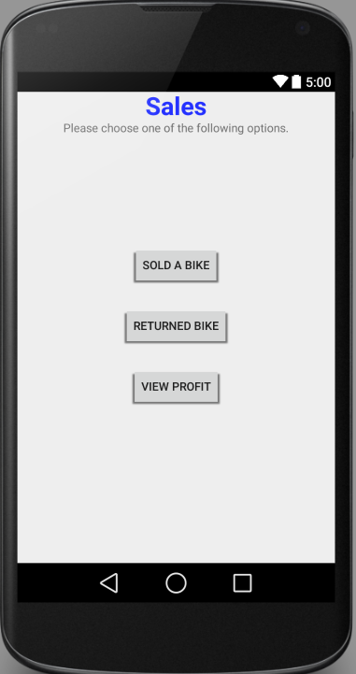All the table information will be selected and will be displayed in a nicely manner on a new page.

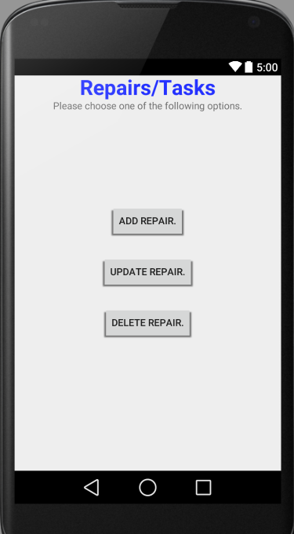

* “Sales” page is accessed once the “Sales” button is pressed from the main page. This page will have three buttons “Sold a Bike”, “Returned Bike” and “View Profit”
* The “Repairs/Tasks” page will come up when “Repairs/Tasks” button is pressed on the main page. It will consist of three buttons “Add Repair”, “Update” and “Delete Repair”.
* SQLite will be the database we use. We will connect the application with the database and make sure it will be working properly. Two tables will be created “Inventory” and “Repairs”.

## Behaviour Requirements

### Use Case View

<A use case defines a goal-oriented set of interactions between external actors and the system under consideration. Since sometimes we will not be able to specify completely the behaviour of the system by just State Diagrams, we use use-cases to complete what we have already started in section 3.3.1.

TO DO: Provide a use case diagram which will encapsulate the entire system and all possible actors. Do not include detailed use case descriptions (these will be needed when you will be working on the Test Plan), but make sure to include a short description of what every use-case is, who are the actors in your diagram. For more information please refer to your UML guide and the MiniThermostat SRS example file.>

# Other Non-functional Requirements

## Performance Requirements

<If there are performance requirements for the product under various circumstances, state them here and explain their rationale, to help the developers understand the intent and make suitable design choices. Specify the timing relationships for real time systems. Make such requirements as specific as possible. You may need to state performance requirements for individual functional requirements or features.

TODO: Provide at least 5 different performance requirements based on the information you collected from the client. For example you can say “1. Any transaction will not take more than 10 seconds, etc…>

## Safety and Security Requirements

<Specify those requirements that are concerned with possible loss, damage, or harm that could result from the use of the product. Define any safeguards or actions that must be taken, as well as actions that must be prevented. Refer to any external policies or regulations that state safety issues that affect the product’s design or use. Define any safety certifications that must be satisfied. Specify any requirements regarding security or privacy issues surrounding use of the product or protection of the data used or created by the product. Define any user identity authentication requirements.

TODO:

* Provide at least 3 different safety requirements based on your interview with the client or, on your ABM related research, and again you need to be creative here.
* Describe briefly what level of security is expected from this product by your client and provide a bulleted (or numbered) list of the major security requirements.>

## Software Quality Attributes

<Specify any additional quality characteristics for the product that will be important to either the customers or the developers. Some to consider are: adaptability, availability, correctness, flexibility, interoperability, maintainability, portability, reliability, reusability, robustness, testability, and usability. Write these to be specific, quantitative, and verifiable when possible. At the least, clarify the relative preferences for various attributes, such as ease of use over ease of learning.

TODO: Use subsections (e.g., 4.3.1 Reliability, 4.3.2 Portability, etc…) provide requirements related to the different software quality attributes. Base the information you include in these subsections on the material you have learned in the class. Make sure, that you do not just write “This software shall be maintainable…” Indicate how you plan to achieve it, & etc…Do not forget to include such attributes as the design for change. Please note that you need to include at least 2 quality attributes, but it is the mere minimum and it will not receive the full marks.>

# Other Requirements

<This section is **Optional.** Define any other requirements not covered elsewhere in the SRS. This might include database requirements, internationalization requirements, legal requirements, reuse objectives for the project, and so on. Add any new sections that are pertinent to the project.>

Appendix A – Data Dictionary

*<Data dictionary is used to track all the different variables, states and functional requirements that you described in your document. Make sure to include the complete list of all constants, state variables (and their possible states), inputs and outputs in a table. In the table, include the description of these items as well as all related operations and requirements.>*

Appendix B - Group Log

<Please include here all the minutes from your group meetings, your group activities, and any other relevant information that will assist the Teaching Assistant to determine the effort put forth to produce this document>